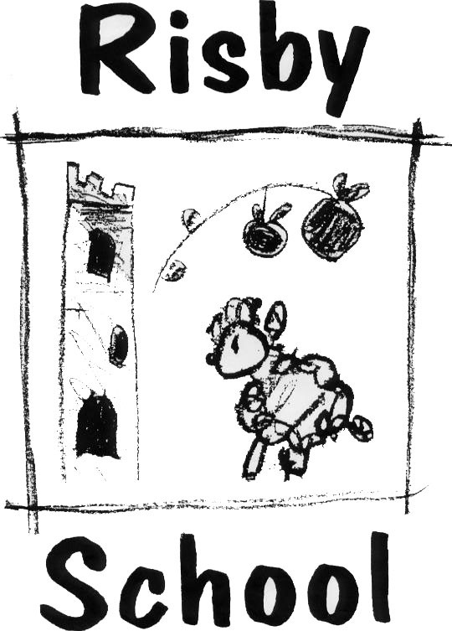

Risby CEVC Primary School

Child Protection and Safeguarding Policy

Prepared by: | Lucy Smith
Approved by: | Full Governing Body
Status & review cycle | Statutory Annual
Date approved: | September 2026
Review date: | September 2027

Safeguarding Team Contacts at Risby CEVC Primary School

Role: | Name and contact details:
Designated Safeguarding Lead (DSL) | Mrs Lucy Smith
Alternate DSL(s) | Mrs Adele Jones
Alternate DSL(s) | Mrs Louise Filby
Named Safeguarding Governor | Mrs Laura Marshall
Chair of Governors | Mr Ben Ramsay
School Online Safety Lead | Mrs Lucy Smith
Designated Teacher for Children in Care and children previously in care (CiC) | Mrs Adele Jones

Table of Contents

- Ethos statement

- Introduction

- Statutory framework

- Key roles and responsibilities

- Induction & Training

- Recognising concerns – signs and indicators of abuse

- Specific safeguarding issues

- Children potentially at greater risk of harm

- Opportunities to teach Safeguarding

- Online safety and filtering & monitoring

- Procedures

- Information sharing, record keeping and confidentiality

- Safeguarding concerns or allegations made about teachers, including supply teachers, other staff, volunteers and contractors.

- Use of school premises for non-school activities

- Whistleblowing

- Useful contacts and links

- Appendix A – MyConcern safeguarding recording system
- Appendix B – Body Map

School Child Protection and Safeguarding Policy Framework
Safeguarding and promoting the welfare of children is everyone’s responsibility. ‘Children’ includes everyone under the age of 18. Everyone who comes into contact with children and their families has a role to play. In order to fulfil this responsibility effectively, all practitioners should make sure their approach is child-centred. This means that they should consider, at all times, what is in the best interests of the child.
(Keeping Children Safe in Education)

Ethos statement
At Risby CEVC Primary School we recognise the moral and statutory responsibility placed on all staff to safeguard and promote the welfare of all children. We aim to provide a safe and welcoming environment, underpinned by a culture of openness where both children and adults feel secure, are able to raise concerns and believe they are being listened to, and that appropriate action will be taken to keep them safe.

Introduction
The governing body* recognises the need to ensure that it complies with its duties under legislation and this policy has regard to statutory guidance, Keeping Children Safe in Education (KCSiE) 2026, Working Together to Safeguard Children and locally agreed inter-agency procedures put in place by Suffolk Safeguarding Partnership.

*In maintained schools the governing body is responsible for ensuring their functions are exercised with a view to safeguarding and promoting the welfare of children in accordance with section 175 of the Education Act 2002, for pupil referral units it is the management committee, in independent schools, including academies and free schools, and 16-19 academies, this duty sits with the proprietor (in the case of academies the proprietor will be the academy trust). References to the governing body throughout this policy framework includes management committees.

This policy will be reviewed annually, as a minimum, and will be made available publicly via the school website or on request.

Safeguarding and promoting the welfare of children is defined as: providing help and support to meet the needs of children as soon as problems emerge, protecting children from maltreatment whether that is within or outside the home, including online; protecting children from maltreatment; preventing impairment of children’s mental and physical health or development; ensuring that children grow up in circumstances consistent with the provision of safe and effective care; and taking action to enable all children to have the best outcomes.

This policy is for all staff, parents, governors, volunteers, supply staff and contractors and the wider school community. It forms part of the child protection and safeguarding arrangements for our school and is one of a suite of policies and procedures which encompass the safeguarding responsibilities of the school. In particular, this policy should be read in conjunction with the school’s Code of Conduct/Staff Behaviour Policy (including Acceptable Use of ICT), Safer Recruitment Policy, Online Safety Policy, Behaviour and Anti-Bullying Policy, school’s guidance on low-level concerns*, Child-on-Child Abuse Policy and procedures, and Part Five of KCSiE 2026, copies of which will be provided to all staff on induction.

*Guidance on Low-Level Concerns may be a stand alone policy or included within another policy e.g. Staff Code of Conduct

The aims of this policy are to:

- Provide staff with a framework to promote and safeguard the wellbeing of children and young people, and ensure that they understand and meet their statutory responsibilities;
- Ensure consistent good practice across the school.

The governing body expects that all staff will have read and understand this child protection and safeguarding policy and their responsibility to implement it. All staff must, as a minimum, read and understand Part One of Keeping Children Safe in Education (KCSiE) 2026. The Part One overview for all staff may be used as a complementary quick reference but does not replace Part One. Governors and senior leaders will ensure that they have read and understand Parts One and Two of KCSiE 2026. Staff with specific safeguarding or safer recruitment responsibilities will read the additional relevant sections of KCSiE 2026, including Part Three where appropriate.

The governing body may decide that staff with particular responsibilities should read additional parts of KCSiE 2026. For example, colleagues involved in safer recruitment administration, including maintenance of the single central record, should also be familiar with Part Three.

The governing body will ensure that arrangements are in place for all staff members to receive appropriate safeguarding and child protection training, which is regularly updated. The governing body will ensure that all governors receive appropriate safeguarding and child protection (including online) at induction, which is regularly updated.

Compliance with the policy will be monitored by the Headteacher, Designated Safeguarding Lead (DSL) and named safeguarding governor.

Statutory framework
Section 175 of the Education Act 2002 in the case of maintained schools and pupil referral units* places a statutory duty on governing bodies to have policies and procedures in place that safeguard and promote the welfare of children and young people who are pupils of the school which must have regard to any guidance given by the Secretary of State.

*Section 175, Education Act 2002 – for management committees of pupil referral units, this is by virtue of
regulation 3 and paragraph 19A of Schedule 1 to the Education (Pupil Referral Units) (Application of Enactments) (England) Regulations 2007

In accordance with statutory guidance, Working Together to Safeguard Children 2026, local safeguarding arrangements must be established for every local authority area by the three safeguarding partners (Local Authority, Police and Integrated Care Boards). All three partners have equal and joint responsibility for a range of roles and statutory functions including developing local safeguarding policy and procedures and scrutinising local arrangements. In Suffolk, schools are relevant agencies and must work in accordance with the multi-agency procedures developed by the Suffolk Safeguarding Partnership (SSP), which can be found on its website at https://suffolksp.org.uk/.

Key roles and responsibilities
Governing Body
The governing body has a strategic leadership responsibility for the school’s safeguarding arrangements and must ensure that they comply with their duties under legislation. The governing body has a legal responsibility to make sure that there are appropriate policies and procedures in place, which have regard to statutory guidance, in order for appropriate action to be taken in a timely manner to safeguard and promote children and young people’s welfare. The governing body will also ensure that the policy is made available to parents and carers by publishing this on the school website or in writing if requested.
The governing body will ensure they facilitate a whole school approach to safeguarding. This means ensuring safeguarding and child protection are at the forefront and underpin all relevant aspects of process and policy development, and that all systems, processes and policies are transparent, clear and easy to understand and operate with the best interests of the child at their heart.
The governing body will ensure that where there is a safeguarding concern, school leaders will make sure the child’s wishes and feelings are taken into account when determining what action to take and what services to provide. Systems will be in place that are well promoted, easily understood and easily accessible for children to confidently report abuse, knowing their concerns will be treated seriously, and knowing they can safely express their views and give feedback.
The governing body will ensure that the school contributes to multi-agency working in line with statutory guidance Working Together to Safeguard Children 2026 and that the school’s safeguarding arrangements take into account the procedures and practice of the locally agreed multi-agency safeguarding arrangements in place.
The governing body will ensure that, as a minimum, the following policies are in place to enable appropriate action to be taken to safeguard and promote the welfare of children and young people as appropriate:

- Child-on-child abuse
- Online safety,
- Behaviour, including measures to prevent bullying (including cyberbullying, prejudice-based and discriminatory bullying)
- Special educational needs and disability
- Supporting pupils in school with medical conditions
- Staff code of conduct/behaviour policy (which should also include the procedures that will be followed to address low-level concerns and allegations made against staff, whistleblowing and acceptable use of IT, including the use of mobile devices staff/pupil relationships and communications, including the use of social media.)
- Procedure for responding to children who go missing from education, particularly on repeat occasions.
- Safer recruitment
It is the responsibility of the governing body to ensure that staff and volunteers are properly vetted to make sure they are safe to work with the pupils who attend our school and that the school has procedures for appropriately managing allegations of abuse made against or low level concerns involving, members of staff (including the Headteacher, supply teachers, contractors, and volunteer helpers).
The governing body will ensure that there is a named governor for safeguarding, a Designated Safeguarding Lead (DSL) who has lead responsibility for safeguarding and child protection, and a designated teacher to promote the educational achievement of children who are looked after, or previously looked after, and will ensure that these people have the appropriate training.

The governing body/proprietor will have regard to their obligations under the Human Rights Act 1998 and the Equality Act 2010 (including the Public Sector Equality Duty).*

*Set out in paragraphs 81-93 of KCSiE

The governing body will inform Suffolk County Council and the SSP annually about the discharge of their safeguarding duties by completing the safeguarding self-assessment audit.

Designated Safeguarding Lead (DSL)
The DSL should take lead responsibility for safeguarding and child protection, including online safety and understanding the filtering and monitoring systems and processes in place. This should be explicit in the roleholder’s job description. The broad areas of responsibility and activities related to the role of the DSL are set out in Annex B of KCSiE 2026.
The DSL will have the appropriate status, authority, time, funding, training, resources and support they need to carry out the duties of the post effectively.
The school also has alternate DSLs who are trained to the same standard as the DSL. The DSL and alternate DSLs will provide advice and support to staff in school and will liaise with the local authority and work with other agencies in line with Working Together to Safeguard Children 2026.
During term time, the DSL and/or an alternate should always be available during school hours for staff to discuss any safeguarding concerns. The DSL will make arrangements for adequate and appropriate cover arrangements for any out of hours/out of term time activities.
The DSL will undergo training to provide them with the knowledge and skills to carry out the role. This training will be updated every two years.

The DSL will liaise with the headteacher to inform them of issues and in particular ongoing enquiries under section 47 of the Children Act 1989 and police investigations.*

* See LA explanatory note on the requirements around children having an appropriate adult Schools-StopSearch-v2.3.pdf (squarespace.com)

Headteacher
The Headteacher will ensure that the policies and procedures adopted by the governing body are fully implemented and that sufficient resources and time and training are provided to enable staff members to discharge their safeguarding responsibilities and contribute effectively to a whole school approach to safeguarding.
The Headteacher will be responsible for ensuring a culture of safety and ongoing vigilance that fosters the belief that ‘it could happen here’.

All staff
All staff have a responsibility to provide a safe environment in which children can learn.
All staff must read and ensure they understand at least Part One of KCSiE 2026, including staff who do not work directly with children. The Part One overview for all staff may be used as a complementary quick reference but does not replace Part One.
*Whilst it is a matter for schools, based on their assessment, SCC and Suffolk Safeguarding Partnership take the view that it should only be those staff that do not have regular contact with children in school, e.g. cleaners who come in out of school hours, who are expected to only read the condensed version of Part One of KCSiE.

All staff must ensure they are familiar with the systems within school which support safeguarding, including the child protection and safeguarding policy, the code of conduct/staff behaviour policy, the behaviour policy, the safeguarding response to children who go missing from education, and the role of the DSL (including the identity of the DSL and any deputies). These will be explained to all staff on induction.

All staff should be aware of indicators of abuse and neglect so that they are able to identify cases of children who may need help or protection. All staff should maintain a belief that ‘it could happen here’ where safeguarding is concerned and if staff have any concerns about a child’s welfare, they must act on them immediately.

All staff should be able to reassure victims that they are being taken seriously and that they will be supported and kept safe. A victim should never be given the impression that they are creating a problem by reporting abuse, sexual violence or sexual harassment. Nor should a victim ever be made to feel ashamed for making a report.

All staff should know what to do if a child tells them he/she is being abused, neglected or exploited, and/or is otherwise at risk of involvement in criminal activity, such as knife crime, or involved in county lines drug dealing.

All staff should be aware of the process for making referrals to children’s social care and for statutory assessments under the Children Act 1989 that may follow a referral, especially section 17 (children in need) and section 47 (a child suffering, or likely to suffer, significant harm) along with the role they might be expected to play in such assessments.

All staff should be aware of, and understand, their role in providing support before statutory intervention, including community-based Early Help and Family Help, in line with Working Together to Safeguard Children 2026 and local Suffolk arrangements. Family Help brings together targeted early help and support under section 17 of the Children Act 1989 to provide a more seamless offer to families. Staff should provide support as soon as problems emerge, liaise with the DSL and share information with other professionals to support early identification, assessment and coordinated planning. Staff may be asked to contribute to, or act as the lead professional for, an assessment or plan where appropriate.

Any child may benefit from support before statutory intervention, including universal services, community-based Early Help or the targeted early help level of Family Help. All school staff should be particularly alert to the potential need for additional support for a child who:

- is disabled or has certain health conditions and has specific additional needs
- has special educational needs (SEN) (whether or not they have a statutory Education, Health and Care Plan)
- has a mental health need
- is a young carer
- is pregnant and/or is a parent themselves
- has exhibited early signs of abusive, violent and/or harmful behaviours
- is showing signs of being drawn in to anti-social or criminal behaviour, including gang involvement and association with organised crime groups or county lines
- is frequently missing/goes missing from care or from home
- has experienced multiple suspensions, is at risk of being permanently excluded from schools, colleges and in Alternative Provision or a Pupil Referral Unit
- is at risk of modern slavery, trafficking or sexual and/or criminal exploitation
- is at risk of being radicalised or exploited
- has a parent or carer in custody, or is affected by parental offending
- is in a family circumstance presenting challenges for the child, such as drug and alcohol misuse, adult mental health issues or domestic abuse
- is misusing alcohol and other drugs themselves
- is at risk of ‘honour’-based abuse such as Female Genital Mutilation (FGM) or forced marriage
- is a privately fostered child

Knowing what to look out for is vital to the early identification of abuse and neglect and specific safeguarding issues such as child criminal exploitation and child sexual exploitation. If staff are unsure, they should always speak to the DSL (or deputy). If in exceptional circumstances the DSL (or deputy) is not available, this should not delay appropriate action being taken. Staff should consider speaking to a member of the senior leadership team and/or take advice from children’s social care. Multi-Agency Safeguarding Hub (MASH) - Suffolk County Council. In these circumstances, any action taken should be shared with the DSL as soon as is practically possible. Details of the school’s safeguarding team are on the front this policy.

The safeguarding leads and named governor can be contacted via the school on the following number: 01284 810367

Induction & Training
The governing body will ensure that all staff receive appropriate safeguarding and child protection training (including online safety, which includes an understanding of the expectations, applicable role and responsibilities in relation to filtering and monitoring) which is regularly updated and in line with advice from the Suffolk Safeguarding Partnership, including the Training — Suffolk Safeguarding Partnership and the Online Safety — Suffolk Safeguarding Partnership. In addition, all staff members will receive regular safeguarding and child protection (including online safety) updates (for example, via email, e-bulletins, staff meetings) as required, but at least annually, to provide them with relevant skills and up to date knowledge of emerging and evolving safeguarding issues to safeguard children effectively.
All new staff members will undergo safeguarding and child protection training at induction. This will include training on the school’s safeguarding and child protection policy, online safety, the code of conduct/staff behaviour policy, low-level concerns guidance, the behaviour policy, the safeguarding response to children who are absent from education, and the role of the designated safeguarding lead. Copies of the school’s policies and procedures and Part One of KCSiE 2026 will be provided to all new staff at induction.

The governing body will ensure that safeguarding training for staff, including online safety training, is integrated, aligned and considered as part of the whole school safeguarding approach and wider staff training and curriculum planning.

The Headteacher will ensure that an accurate record of safeguarding training undertaken by all staff is maintained and updated regularly.

In considering safeguarding training arrangements the governing body will also have regard to the Teachers’ Standards which set out the expectation that all teachers manage behaviour effectively to ensure a good and safe educational environment, and require teachers to have a clear understanding of the needs of all pupils.

Recognising concerns - signs and indicators of abuse, neglect and exploitation.
All staff should be aware of the indicators of abuse, neglect and exploitation (see below), understanding that children can be at risk of harm inside and outside of the school, inside and outside of home, and online. Exercising professional curiosity and knowing what to look for is vital for the early identification of abuse and neglect so that staff are able to identify cases of children who may be in need of help or protection.

All school and college staff should be aware that abuse, neglect, exploitation, and safeguarding issues are rarely standalone events and cannot be covered by one definition or one label alone. In most cases, multiple issues will overlap.

All staff, but especially the designated safeguarding lead (and deputies) should consider whether children are at risk of abuse or exploitation in situations outside their families. Extra familial harms take a variety of different forms and children can be vulnerable to multiple harms including (but not limited to) sexual abuse (including harassment and exploitation), domestic abuse in their own intimate relationships (teenage relationship abuse), criminal exploitation, serious youth violence, county lines and radicalisation.

All staff should be aware that technology is a significant component in many safeguarding and wellbeing issues. Children are at risk of abuse and other risks online as well as face to face. In many cases abuse and other risks will take place concurrently both online and offline. Children can also abuse other children online, this can take the form of abusive, harassing, and misogynistic/misandrist messages, the non-consensual sharing of indecent images, especially around chat groups, and the sharing of abusive images and pornography to those who do not want to receive such content.

In all cases, if staff are unsure, they should always speak to the DSL or deputy.

Indicators of abuse and neglect

Abuse is defined as a form of maltreatment of a child. Somebody may abuse or neglect a child by inflicting harm or by failing to act to prevent harm. Harm can include ill treatment that is not physical as well as the impact of witnessing ill treatment of others. This can be particularly relevant, for example, in relation to the impact on children of all forms of domestic abuse including where they see, hear or experience its effects. Children may be abused in a family or in an institutional or community setting by those known to them or, more rarely, by others. Abuse can take place wholly online, or technology may be used to facilitate offline abuse. They may be abused by an adult or adults or another child or children.

The following indicators listed under the categories of abuse are not an exhaustive list:

Physical abuse: a form of abuse which may involve hitting, shaking, throwing, poisoning, burning or scalding, drowning, suffocating or otherwise causing physical harm to a child. Physical harm may also be caused when a parent or carer fabricates the symptoms of, or deliberately induces, illness in a child.
Emotional abuse: the persistent emotional maltreatment of a child such as to cause severe and adverse effects on the child’s emotional development. It may involve conveying to a child that they are worthless or unloved, inadequate, or valued only insofar as they meet the needs of another person. It may include not giving the child opportunities to express their views, deliberately silencing them or ‘making fun’ of what they say or how they communicate. It may feature age or developmentally inappropriate expectations being imposed on children. These may include interactions that are beyond a child’s developmental capability as well as overprotection and limitation of exploration and learning or preventing the child participating in normal social interaction. It may involve seeing or hearing the ill-treatment of another. It may involve serious bullying (including cyberbullying), causing children frequently to feel frightened or in danger, or the exploitation or corruption of children. Some level of emotional abuse is involved in all types of maltreatment of a child, although it may occur alone.
Sexual abuse: involves forcing or enticing a child or young person to take part in sexual activities, not necessarily involving violence, whether or not the child is aware of what is happening. The activities may involve physical contact, including assault by penetration (for example rape or oral sex) or non-penetrative acts such as masturbation, kissing, rubbing and touching outside of clothing. They may also include non-contact activities, such as involving children in looking at, or in the production of, sexual images, watching sexual activities, encouraging children to behave in sexually inappropriate ways, or grooming a child in preparation for abuse (including via the internet). Sexual abuse is not solely perpetrated by adult males. Women can also commit acts of sexual abuse, as can other children. The sexual abuse of children by other children is a specific safeguarding issue (also known as child-on-child abuse) in education and all staff should be aware of it and of the school’s policy and procedures for dealing with it. (See section 7: Specific safeguarding issues)
Neglect: the persistent failure to meet a child’s basic physical and/or psychological needs, likely to result in the serious impairment of the child’s health or development. Neglect may occur during pregnancy as a result of maternal substance abuse. Once a child is born, neglect may involve a parent or carer failing to: provide adequate food, clothing and shelter (including exclusion from home or abandonment); protect a child from physical and emotional harm or danger; ensure adequate supervision (including the use of inadequate caregivers); or ensure access to appropriate medical care or treatment. It may also include neglect of, or unresponsiveness to, a child’s basic emotional needs.
(Source Keeping Children Safe in Education)

Specific safeguarding issues
All staff should have an awareness of safeguarding issues that can put children at risk of harm. Behaviours linked to issues such as of drug taking and/or alcohol misuse, unexplainable and/or persistent absences from education, serious violence (including that linked to county lines) radicalisation and consensual and non-consensual sharing of nude and semi-nude images and/or videos can be signs that children are at risk. Other safeguarding issues all staff should be aware of include:

Child-on-child abuse
All staff should be aware that children can abuse other children (often referred to as child-on-child abuse) and that it can happen both inside and outside of school - and online. It is important that all staff recognise the indicators and signs of child-on-child abuse and know how to identify it and respond to reports.

All staff should understand that even if there are no reports in school it does not mean it is not happening; it may be that it is simply not being reported. If staff have any concerns regarding child-on-child abuse, they should speak to the DSL (or deputy) and record the concern promptly on MyConcern.

It is essential that all staff understand the importance of challenging inappropriate behaviours between children, many of which are listed below, that are abusive in nature. Downplaying certain behaviours, for example dismissing sexual harassment as “just banter”, “just having a laugh”, “part of growing up” or “boys being boys” can lead to a culture of unacceptable behaviours, an unsafe environment for children and in worst case scenarios a culture that normalises abuse leading to children accepting it as normal and not coming forward to report it.

Child-on-child abuse is most likely to include, but may not be limited to:

- bullying (including cyberbullying, prejudice-based and discriminatory bullying)
- Abuse in intimate personal relationships between children (sometimes known as ‘teenage relationship abuse’)
- physical abuse such as hitting, kicking, shaking, biting, hair pulling, or otherwise causing physical harm (this may include an online element which facilitates, threatens and/or encourages physical abuse)
- sexual violence, such as rape, assault by penetration and sexual assault (this may include an online element which facilitates, threatens and/or encourages sexual violence)
- sexual harassment, such as sexual comments, remarks, jokes and online sexual harassment, which may be stand-alone or part of a broader pattern of abuse.
- Causing someone to engage in sexual activity without consent, such as forcing someone to strip, touch themselves sexually, or to engage in sexual activity with a third party.
- consensual and non-consensual making or sharing of nudes and semi-nudes, including images that are digitally altered or wholly generated using artificial intelligence (for example, deepfakes or deep nudes)
- upskirting, which typically involves taking a picture under a person’s clothing without their permission, with the intention of viewing their genitals or buttocks to obtain sexual gratification, or cause the victim humiliation, distress or alarm; and
- initiation/hazing type violence and rituals (this could include activities involving harassment, abuse or humiliation used as a way of initiating a person into a group and may also include an online element)

All staff should be clear about the school’s policy and procedures with regards to child-on-child abuse and the important role they must play in preventing it and responding where they believe a child may be at risk from it.

Child sexual exploitation (CSE) and Child Criminal Exploitation (CCE)
Both CSE and CCE are forms of abuse and both occur where an individual or group takes advantage of an imbalance of power to coerce, manipulate or deceive a child into taking part in sexual or criminal activity, in exchange for something the victim needs or wants, and/or for the financial advantage or increased status of the perpetrator or facilitator and/or through violence or the threat of violence. CSE and CCE can affect children, both male and female and can include children who have been moved (commonly referred to as trafficking) for the purpose of exploitation.

Child Criminal Exploitation (CCE)
Some specific forms of CCE can include children being forced or manipulated into transporting drugs or money through county lines, working in cannabis factories, shoplifting or pickpocketing. They can also be forced or manipulated into committing vehicle crime or threatening/committing serious violence to others.

Children can become trapped by this type of exploitation as perpetrators can threaten victims (and their families) with violence, or entrap and coerce them into debt. They may be coerced into carrying weapons such as knives or begin to carry a knife for a sense of protection from harm from others. As children involved in criminal exploitation often commit crimes themselves, their vulnerability as victims is not always recognised by adults and professionals (particularly older children), and they are not treated as victims despite the harm they have experienced. They may still have been criminally exploited even if the activity appears to be something they have agreed or consented to.

It is important to note that the experience of girls who are criminally exploited can be very different to that of boys. The indicators may not be the same, however staff should be aware that girls are at risk of criminal exploitation too. It is also important to note that both boys and girls being criminally exploited may be at higher risk of sexual exploitation.

Child Sexual Exploitation (CSE)
CSE is a form of child sexual abuse. Sexual abuse may involve physical contact, including assault by penetration (for example, rape or oral sex) or nonpenetrative acts such as masturbation, kissing, rubbing, and touching outside clothing. It may include non-contact activities, such as involving children in the production of sexual images, forcing children to look at sexual images or watch sexual activities, encouraging children to behave in sexually inappropriate ways or grooming a child in preparation for abuse including via the internet.

CSE can occur over time or be a one-off occurrence, and may happen without the child’s immediate knowledge e.g. through others sharing videos or images of them on social media.

CSE can affect any child, who has been coerced into engaging in sexual activities. This includes 16 and 17 year olds who can legally consent to have sex. Some children may not realise they are being exploited e.g. they believe they are in a genuine romantic relationship.

Further information on signs of a child’s involvement in sexual exploitation is available in Child sexual exploitation: definition and guide for practitioners - GOV.UK

Domestic abuse
Domestic abuse can encompass a wide range of behaviours and may be a single incident or a pattern of incidents. The abuse can be, but not limited to, psychological, physical, sexual, financial or emotional. Children can be victims of domestic abuse. They may see, hear, or experience the effects of abuse at home and/or suffer domestic abuse in their own intimate relationships (teenage relationship abuse). All of which can have a detrimental and long term impact on their health, well-being, development and ability to learn.

Female Genital Mutilation (FGM)
Whilst all staff should speak to the DSL (or deputy) with regard to any concerns about FGM, there is a specific legal duty on teachers*. If a teacher, in the course of their work in the profession, discovers that an act of FGM appears to have been carried out on a girl under the age of 18, the teacher must report this to the police.

* Under section 5B(11) (a) of the Female Genital Mutilation Act 2003, ‘teacher’ means, in relation to England, a person within section 141A(1) of the Education Act 2002 (persons employed or engaged to carry out teaching work at schools and other institutions in England)

Mental Health
All staff should be aware that mental health problems can, in some cases, be an indicator that a child has suffered or is at risk of suffering abuse, neglect or exploitation.

Only appropriately trained professionals should attempt to make a diagnosis of a mental health problem. Education staff, however, are well placed to observe children day-to-day and identify those whose behaviour suggests that they may be experiencing a mental health problem or be at risk of developing one.

Where children have suffered abuse and neglect, or other potentially traumatic adverse childhood experiences, this can have a lasting impact throughout childhood, adolescence and into adulthood. It is key that staff are aware of how these children’s experiences can impact on their mental health, behaviour and education.

Staff can access a range of advice to help them identify children in need of extra mental health support, this includes working with external agencies

If staff have a mental health concern about a child that is also a safeguarding concern, immediate action should be taken, following the school’s policy, and speaking to the DSL or a deputy.

Serious violence
All staff should be aware of the indicators, which may signal that children are at risk from, or involved with, serious violent crime. These may include increased absence from school, a change in friendships or relationships with older individuals or groups, a significant decline in performance, signs of self-harm or a significant change in wellbeing, or signs of assault or unexplained injuries. Unexplained gifts or new possessions could also indicate that children have been approached by, or are involved with, individuals associated with criminal networks or gangs and may be at risk of criminal exploitation.

Preventing radicalisation
Children may be susceptible to radicalisation into terrorism. Similar to protecting children from other forms of harms and abuse, protecting children from this risk should be a part of a schools safeguarding approach. For further information see Page 157 of Keeping Children Safe in Education 2026.

Channel
Channel is a voluntary, confidential support programme which focuses on providing support at an early stage to people who are identified as being susceptible to being drawn into terrorism. Prevent referrals are assessed and may be passed to a multi-agency Channel panel, which will discuss the individual referred to determine whether they are at risk of being drawn into terrorism and consider the appropriate support required. For further information see Page 158 of Keeping Children Safe in Education 2026.

Children potentially at greater risk of harm
The governing body recognise that whilst all children should be protected there are some groups of children who are potentially at greater risk of harm and, in some cases, these children may find it difficult to communicate what is happening to them.

Where a school places a pupil with an alternative provision provider, it continues to be responsible for the safeguarding of that pupil and should be satisfied that the placement meets the pupil’s needs.
- Schools should obtain written confirmation from alternative provision providers that the necessary safeguarding and employment checks have been completed for all staff in line with statutory guidance.
- Schools should also be advised about any changes that might put the child at risk, e.g. staff changes, so the school can make sure appropriate safeguarding checks have been carried out.
- Schools must know where a child is during school hours, including the address of any alternative provider, subcontracted provision or satellite site.
- Schools should regularly review the alternative provision placements, at least half termly.
- Where safeguarding concerns arise, the placement should be immediately reviewed, and terminated, if necessary.

The governing body recognises that pupils placed in alternative provision may have complex needs and may be vulnerable to additional risks of harm.

The governing body will have regard to the following statutory guidance:
Arranging Alternative Provision - guide for LAs and schools and Education for children with health needs who cannot attend school – DfE Statutory Guidance

Children who need a social worker (Child in Need and Child Protection Plans)
Children may need a social worker due to complex safeguarding or welfare needs. Children may need this help due to abuse, neglect and complex family circumstances. A child’s experiences of adversity and trauma can leave them vulnerable to further harm, as well as educationally disadvantaged in facing barriers to attendance, education, behaviour and mental health.

The governing body expects that the Local Authority will share the fact a child has a social worker, and the DSL will hold and use this information so that decisions can be made in the best interests of the child’s safety, welfare and educational outcomes. This should be considered as a matter of routine. There are clear powers to share this information under existing duties on both LAs and school to safeguard and promote the welfare of children.

Where children need a social worker, this should inform decisions about safeguarding (for example, responding to unauthorised absence or missing education where there are known safeguarding risks) and about promoting welfare (for example, considering the provision of pastoral and/or academic support, alongside action by statutory services.

Children absent from education
A child being absent from education, particularly repeatedly, can be a warning sign of a range of safeguarding issues. This might include abuse or neglect, such as sexual abuse or exploitation or child criminal exploitation, or issues such as mental health problems, substance abuse, radicalisation, FGM or forced marriage.

There are many circumstances where a child may be absent or become missing from education, but some children are particularly at risk. These include children who:

- Are at risk of harm or neglect
- Are at risk of forced marriage or FGM
- Come from Gypsy, Roma, or Traveller families
- Come from the families of service personnel
- Go missing or run away from home or care
- Are supervised by the youth justice system
- Cease to attend a school
- Come from new migrant families

It is important that the school’s procedures for unauthorised absence and for dealing with children who are absent from education are followed, particularly on repeat occasions, to help identify the risk of abuse and neglect, including sexual exploitation, and to help prevent the risks of going missing in future. This includes when problems are first emerging but also where children are already known to LA children’s social care and need a social worker (such as on a child in need or child protection plan, or as a looked after child), where absence from education may increase known safeguarding risks within the family or in the community. As such, all staff should be aware of the school’s unauthorised absence procedures and children missing education procedures.

This includes informing the LA if a child leaves the school without a new school being named and adhering to requirements with respect to sharing information with the LA, when applicable, when removing a child’s name from the admission register at non-standard transition points.
Staff will be trained in signs to look out for and the individual triggers to be aware of when considering the risks of potential safeguarding concerns which may be related to being absent, such as travelling to conflict zones, FGM and forced marriage.

Further information and support includes:
- schools’ duties regarding children missing education, including information schools must provide to the LA when removing a child from the school roll at standard and non-standard transition points can be found in the DfE’s statutory guidance: Children Missing Education.
- General information and advice for schools can be found in the Government’s Missing Children and Adults Strategy.
- further information for colleges providing education for a child of compulsory school age can be found in: Full-time-Enrolment of 14 to 16 year olds in Further Education and Sixth Form Colleges
- guidance for schools concerning children who are absent from education Working Together To Improve School Attendance

Elective Home Education
Many home educated children have a positive learning experience. We would expect the parents’ decision to home educate to be made with their child’s best education at the heart of the decision. However, this is not the case for all. Elective home education can mean that some children are not in receipt of suitable education and are less visible to the services that are there to keep them safe and supported in line with their needs.

Where a parent/carer has expressed their intention to remove a child from school with a view to educating at home, the school will work together with the LA and other key professionals to coordinate a meeting with parents/carers where possible.

Ideally this would be before a final decision has been made to, to ensure the parents/carers have considered what is in the best interests of each child. This is particularly important where a child has SEND, is vulnerable, and/or has a social worker. Where a child has an Education, Health and Care plan in place the LA will need to review the plan, working closely with parents and carers.

Children requiring mental health support
Mental health problems can, in some cases, be an indicator that a child has suffered or is at risk of suffering abuse, neglect or exploitation.

The governing body will ensure there is a clear system and process in place for identifying possible mental health problems, including routes to escalate, and a clear referral and accountability system.

Staff can access further advice in a DfE guidance documents Preventing and tackling bullying and mental health and behaviour in schools which set out how staff can help prevent mental health problems by promoting resilience as part of an integrated, whole school approach to social and emotional wellbeing, which is tailored to the needs of pupils.

Looked after children and previously looked after children.
The most common reason for children becoming looked after is as a result of abuse and/or neglect. The governing body will ensure staff have the skills, knowledge and understanding to keep looked after children safe.

The governing body will ensure there are arrangements in place so that appropriate staff have the information they need in relation to a child’s looked after legal status (whether they are looked after under voluntary arrangements with consent of parents, or on an interim or full care order) and the child’s contact arrangements with birth parents or those with parental responsibility.

Appropriate staff will also have information about the child’s care arrangements and the levels of authority delegated to the carer by the authority looking after the child. The DSL should have the details of the child’s social worker and the name of the virtual school head in the authority that looks after the child.

A previously looked after child potentially remains vulnerable and all staff should have the skills, knowledge and understanding to keep previously looked after children safe. The governing body recognise that when dealing with looked after children and previously looked after children, it is important that all agencies work together and prompt action is taken when necessary to safeguard these children, who are a particularly vulnerable group.

For children who are care leavers, the DSL should have details of the LA Personal Advisor appointed to guide and support the care leaver and liaise with them as necessary regarding any issues of concern.

Children with SEN and disabilities, and/or physical health issues can face additional safeguarding challenges, both online and offline.

Staff should avoid making assumptions that indicators of possible abuse such as behaviour, mood and injury may relate to the child’s disability or medical condition without further exploration.

Staff should also be aware that these children may be more prone to peer group isolation or bullying (including prejudice-based bullying) than other children. Similarly, staff should be aware of the potential for children with SEND or certain medical conditions being disproportionately impacted by behaviours such as bullying without outwardly showing signs or being able to communicate how they are feeling.

Staff also need to be mindful of children’s cognitive understanding, for example, whether they are able to understand the difference between fact and fiction in online content and the consequences of repeating the content/behaviours in school.

As such, any reports of abuse involving children with SEND will require close liaison with the DSL and SENCO.

Further information can be found in the DfE’s:

- SEND Code of Practice 0 to 25 years, and
- Supporting Pupils at School with Medical Conditions
- Children with special educational needs and disabilities (SEND) | NSPCC Learning
- NSPCC - Safeguarding child protection/deaf and disabled children and young people

Children who are lesbian, gay or bisexual

The governing body acknowledges that a child or young person being lesbian, gay or bisexual is not in itself a risk factor for harm. However, children who are lesbian, gay or bisexual, or who are perceived by others to be lesbian, gay or bisexual, can be vulnerable to discriminatory bullying. The school will consider how to address these vulnerabilities, prevent bullying and respond appropriately where concerns arise.

Children who are lesbian, gay or bisexual may face additional barriers to reporting concerns where they lack a trusted adult with whom they can be open. Staff should work to reduce these barriers and ensure children have safe and accessible ways to seek help.

Children who are questioning their gender should be supported in accordance with KCSiE 2026. The school will take time to understand the child’s thoughts, feelings and wider circumstances; remain professionally curious about any safeguarding, mental health or psychosocial needs; take a strong approach to preventing bullying; and follow the statutory KCSiE 2026 framework when responding to any request relating to social transition. Decisions will be made carefully, in the best interests of the child, with appropriate parental involvement and clear records, subject to safeguarding considerations.

Opportunities to teach safeguarding
The governing body will ensure that children and young people are taught about how to keep themselves and others safe, including online.

The governing body recognise that effective education should be tailored to the specific needs and vulnerabilities of individual children, including children who are victims of abuse, and children with SEND.

Relevant topics will be included within Relationships Education (primary schools) and Relationships and Sex Education (also known as Sex and Relationship Education) (secondary schools) and through Health Education (all pupils in state funded schools), having regard to statutory guidance.

Preventative education is most effective in the context of a whole-school approach that prepares children and young people for life in modern Britain and creates a culture of zero tolerance for sexism, misogyny/misandry, homophobia, biphobia and sexual violence/harassment.

The governing body expect that the school’s values and standards should be upheld and demonstrated throughout all aspects of school life. These will be underpinned by the school’s behaviour policy and pastoral support system, as well as by a planned programme of evidence-based RSHE delivered in regularly timetabled lessons and reinforced throughout the whole curriculum. This whole-school approach will be fully inclusive and developed to be age and stage of development appropriate, and will tackle (in age-appropriate stages) issues such as:

- Healthy and respectful relationships
- Boundaries and consent
- Stereotyping, prejudice and equality
- Body confidence and self-esteem
- How to recognise an abusive relationship, including coercive and controlling behaviour
- The concepts of, and laws relating to – sexual consent, sexual exploitation, abuse, grooming, coercion, harassment, rape, domestic abuse, so called honour-based violence such as forced marriage and FGM, and how to access support, and
- What constitutes sexual harassment and sexual violence and why these are always unacceptable.

Online safety and filtering and monitoring
The school will ensure that there are appropriate filters and monitoring systems in place to safeguard children and young people from potentially harmful and inappropriate online material.

The use of technology has become a significant component of many safeguarding issues such as child sexual exploitation, radicalisation and sexual predation and technology often provides the platform that facilitates such harm.

The governing body has had due regard to the additional information and support set out in KCSiE 2026 and ensures that the school has a whole-school approach to online safety and a clear policy on the use of communications technology in school. Online safety will be a running and interrelated theme when devising and implementing policies and procedures. This will include considering how online safety is reflected in all relevant policies and when planning the curriculum, staff training, the role of the DSL and parental engagement.

It is essential that children are safeguarded from potentially harmful and inappropriate online material. The school adopts a whole school approach to online safety to protect and educate pupils and staff in their use of technology, and establishes mechanisms to identify, intervene in, and escalate any concerns as appropriate.

Online safety issues can be categorised into four areas of risk:
- Content: being exposed to illegal, inappropriate or harmful content, for example, pornography, racism, misogyny, self-harm, suicide, anti-Semitism, or radicalisation or extremism, misinformation, disinformation (including fake news) and conspiracy theories.
- Contact: being subjected to harmful online interaction with other users, for example, peer to peer pressure, commercial advertising, and adults posing as children or young adults with the intention to groom or exploit them for sexual, criminal, financial or other purposes.
- Conduct: online behaviour that increases the likelihood of, or causes, harm, for example, making, sending and receiving explicit images (e.g. consensual and non-consensual sharing of nudes and semi-nudes and/or pornography, sharing other explicit images, and online bullying); and
- Commerce: risks such as online gambling, inappropriate advertising, phishing and/or financial scams. If staff feel that either they or pupils are at risk this should be reported to the Anti-Phishing Working Group (https://apwg.org/).

The governing body will ensure that an annual review is undertaken of the school’s approach to online safety including the school’s filtering and monitoring provision, supported by an annual risk assessment that considers and reflects the risks pupils face online. The review should include a member of the senior leadership team, the DSL, the IT service provider and a governor. The school should ensure they have the appropriate level of security protection procedures in place in order to safeguard their systems, staff and learners and review the effectiveness of these procedures periodically to keep up with evolving cyber-crime technologies. Guidance on cyber security including considerations can be found at Cyber security training for school staff - NCSC.GOV.UK
Also see the schools On-line Safety Policy.

The school’s online safety policy outlines the appropriate filtering and monitoring which take place on school devices and school networks. It also outlines the expectations, applicable roles and responsibilities in relation filtering and monitoring.

The Department for Education’s Meeting digital and technology standards in schools and colleges - Filtering and monitoring standards for schools and colleges - Guidance - GOV.UK set out that schools and colleges should:
• identify and assign roles and responsibilities to manage filtering and monitoring systems.
• review filtering and monitoring provision at least annually.
• block harmful and inappropriate content without unreasonably impacting teaching and learning.
• have effective monitoring strategies in place that meet their safeguarding needs.

The Department has published Generative AI: product safety expectations - GOV.UK to support schools to use generative artificial intelligence safely and explains how filtering and monitoring requirements apply to the use of generative AI in education

As part of our online safety policy, children are not allowed to bring to school any smart device e.g phones or watches that can send/receive messages; has internet-enabling features or can take photos.

School staff can access further safeguarding information and support in Annex A of KCSiE 2026.

11. Procedures
If staff notice any indicators of abuse/neglect or signs that a child or young person may be experiencing a safeguarding issue, they should record the concern promptly on MyConcern. The DSL/deputy should be alerted without delay in accordance with the school’s safeguarding procedures. Recording a concern on MyConcern must not delay immediate action where a child may be at risk of harm.

What to do if you are concerned.
If a child makes an allegation or disclosure of abuse against an adult or other child or young person, it is important that you:
- Stay calm and listen carefully;
- Accept what is being said;
- Allow the child/young person to talk freely – do not interrupt or put words in the child/young person’s mouth;
- Only ask questions when necessary to clarify, do not investigate or ask leading questions;
- Reassure the child, but don’t make promises which it might not be possible to keep;
- Do not promise confidentiality;
- Emphasise that it was the right thing to tell someone;
- Reassure them that what has happened is not their fault;
- Do not criticise the perpetrator;
- Explain what has to be done next and who has to be told;
- Make a written record, which should be signed and include the time, date and your position in school;
- Do not include your opinion without stating it is your opinion;
- Pass the information to the DSL or alternate without delay;
- Consider seeking support for yourself and discuss this with the DSL as dealing with a disclosure can be distressing.

When a safeguarding concern is recorded on MyConcern, the DSL/deputy will review and assess it and record appropriate actions, decisions and outcomes on the system. Taking into account any other safeguarding information known about the child/young person, the DSL will consider whether the concern suggests that the threshold of significant harm, or risk of significant harm, has been reached or whether the child may be in need. If the DSL is unsure whether the threshold has been met, they will contact the MASH Professional Consultation Line for advice (0345 606 1499). Where appropriate, the DSL will complete and submit the SCC multi agency referral form (MARF) (available on the SSP website)*.

Where the DSL believes that a child or young person may be at imminent and significant risk of harm they should call Customer First immediately and then complete the SSP MARF within 24 hours to confirm the referral. In these circumstances, it is important that any consultation should not delay a referral to Customer First.

Where a safeguarding concern does not meet the threshold for a statutory child protection referral, the DSL should record how this decision has been reached and consider whether the child and family would benefit from support before statutory intervention, including community-based Early Help or Family Help, in line with local Suffolk arrangements and Working Together to Safeguard Children 2026.

School staff might be required to contribute to multi-agency plans to provide additional support to children. This might include attendance at child protection conferences or core group meetings. The school is committed to providing as much relevant up to date information about the child as possible, including submitting reports for child protection conferences in advance of the meeting in accordance with SSP procedures and timescales.

Where reasonably possible, the school is committed to obtaining more than one emergency contact number for each pupil.

School staff must ensure that they are aware of the procedure to follow when a child goes missing from education.

Procedures for reporting and escalating concerns about child-on-child abuse follow the same procedures as other safeguarding concerns.

12. Information sharing, record keeping and confidentiality
Information sharing is vital in safeguarding children by identifying and tackling all forms of abuse and neglect, and in promoting children’s welfare, including in relation to their educational outcomes. Schools have clear powers to share, hold and use information for these purposes.

As part of meeting a child’s needs, the school understands that effective and timely information sharing between professionals and local agencies is critical and will contribute to multi-agency working in line with Working Together to Safeguard Children 2026. Data protection law is not a barrier to sharing information where this is necessary and proportionate for safeguarding. The school will have regard to the Data Protection Act 2018, UK GDPR and the Data (Use and Access) Act 2025, as well as current government information-sharing advice for safeguarding practitioners. Staff should not assume that a colleague or another professional will take action or share information that may be critical to keeping a child safe. If in doubt, staff should speak to the DSL or a deputy.

Well-kept records are essential to good child protection practice. All concerns, discussions and decisions made and the rationale for those decisions should be recorded in writing. If in doubt about recording requirements, staff should discuss with the DSL.

The school recognises that confidentiality should be maintained in respect of all matters relating to child protection. Information on individual child protection cases may be shared by the DSL or alternate DSL with other relevant members of staff. This will be on a ‘need to know’ basis and where it is in the child’s best interests to do so.

A member of staff must never guarantee confidentiality to anyone about a safeguarding concern (including parents/carers or pupils), or promise a child to keep a secret which might compromise the child’s safety or wellbeing.

Data protection law allows schools to share information where necessary for safeguarding and, in limited circumstances, to withhold information where disclosure would put a child at risk of serious harm. This may be particularly relevant where a child is affected by domestic abuse perpetrated by a parent or carer, is in a refuge or other emergency accommodation, and the serious harm test is met.

Where a child is suffering, or is likely to suffer from harm, it is important that a referral to local authority children’s social care and if appropriate the police, (see When to Call the Police: Guidance for schools and colleges (npcc.police.uk)) is made immediately. Referrals should follow the local referral process.

Ordinarily, the school will always undertake to share its intention to refer a child to Social Care with their parents /carers unless to do so could put the child at greater risk of harm or impede a criminal investigation. It would be legitimate to share information without consent where: it is not possible to gain consent; it cannot reasonably be expected that a practitioner gains consent; and, if to gain consent would put a child at risk. If in doubt, staff will consult with the MASH Professional Consultation Line on this point.

The school will have regard to SCC Guidance for schools on maintaining and transferring pupil safeguarding/child protection records. Where a child leaves the school, the DSL will ensure their child protection file is transferred to the new school as soon as possible (within 5 days for an in-year transfer or within the first 5 days of the start of a new term). The file will be transferred separately from the main pupil file, ensuring secure transit, and confirmation of receipt should be obtained.

13. Safeguarding concerns or allegations made about teachers, including supply teachers, other staff, volunteers and contractors

The school will follow the SSP Arrangements for Managing Allegations of Abuse Against People Who Work With Children or Those Who Are in A Position of Trust if a safeguarding concern or allegation is raised against an adult in a position of trust which meets the harm threshold.

An allegation that may meet the harm threshold is any information which indicates that a member of staff /volunteer may have:

- Behaved in a way that has harmed a child, or may have harmed a child;
- Possibly committed a criminal offence against or related to a child; or
- Behaved towards a child or children in a way that indicates he/she may pose a risk of harm to children; and/or
- Behaved or may have behaved in a way that indicates they may not be suitable to work with children.

This applies to any child the member of staff, supply teacher, volunteer or contractor has contact with in their personal, professional or community life. It also applies regardless of whether the alleged abuse took place in our school.

Concerns that do not meet the harm threshold will be dealt with in accordance with the school’s policy for managing low-level concerns.

If any member of staff has concerns that a colleague, supply teacher, volunteer or contractor might pose a risk to children, it is their duty to report these to the Headteacher. Where the concerns or allegations are about the Headteacher, these should be referred to the Chair of Governors.
The Headteacher/Chair of Governors should report the concern to the Local Authority Designated Officer (LADO) within one working day.

The corporate director for Children and Young People’s Services, has identified dedicated staff to undertake the role of LADO. LADOs can be contacted via email on LADO@suffolk.gov.uk or by using the LADO central telephone number: 0300 123 2044 for allegations against all staff and volunteers.

14. Use of school premises for non-school activities
The governing body will ensure that where school facilities/premises are hired or rented out to organisations or individuals, sports associations or service providers to run community or extra-curricular activities appropriate arrangements are in place to keep children safe.

The governing body will seek assurance that the body concerned has appropriate child protection and safeguarding policies and procedures in place, including inspecting these as needed. Arrangements will also be put in place for the body hiring or renting the school facilities or premises to liaise with the school on these matters where appropriate.

These arrangements will apply regardless of whether or not the children who attend any of these services or activities are children on the school roll.

Where a lease or hire agreement is entered into the governing body will ensure safeguarding requirements are included as a condition of use and occupation of the premises; this will make clear that any failure to comply would lead to termination of the agreement. The guidance on Keeping children safe in out-of-school settings details the safeguarding arrangements that schools and colleges should expect these providers to have in place.

15. Whistleblowing
The governing body recognises that children cannot be expected to raise concerns in an environment where staff fail to do so. All staff and volunteers should feel able to raise concerns about poor or unsafe practice and potential failures in the school’s safeguarding regime and know that such concerns will be taken seriously by the senior leadership team.
Whistleblowing is ‘making a disclosure in the public interest’ and occurs when a worker (or member of the wider school community) raises a concern about danger or illegality that affects others, for example, pupils in the school or members of the public.
The governing body would wish for everyone in the school community to feel able to report any child protection/safeguarding concerns through existing procedures within school, including the whistleblowing procedure adopted by governors where necessary. However, for members of staff who do not feel able to raise such concerns internally, there is a NSPCC whistleblowing helpline. Staff can call 0800 028 0285 (line available from 8.00am to 8.00pm, Monday to Friday) or email: help@nspcc.org.uk
16. Useful Contacts:
Multi-agency Safeguarding Hub (MASH) Professional Helpline: 0345 606 1499

MASH webchat facility

Customer First (Professional Referral Line) for use in emergencies only: 0345 606 6167
Customer First: 0808 800 4005
Police (emergency only): 999
Suffolk Police main switchboard: 01473 613500
Suffolk Police Cybercrime Unit: 101
Suffolk Local Safeguarding Partnership www.suffolksp.org.uk
Suffolk County Council: www.suffolk.gov.uk/community-and-safety/staying-safe-online/e-safer-suffolk/
LADO 0300 123 2044 or lado@suffolk.gov.uk or on the LADO pages on Suffolk Safeguarding Partnership website

17. Appendix A – MyConcern safeguarding recording system

Safeguarding concerns are recorded and managed electronically using MyConcern.
All staff are expected to record safeguarding and wellbeing concerns promptly on MyConcern, using clear, factual and child-centred language. Records should include the nature of the concern, relevant dates and times, the child’s own words where appropriate, and any immediate action taken. The DSL/deputy will review concerns and record subsequent actions, decisions and outcomes within MyConcern.

MyConcern provides the school’s secure safeguarding chronology and record of concerns.
Where a concern is urgent, or a child may be at immediate risk, staff must also speak directly to the DSL/deputy without delay; entering information on MyConcern must not delay protective action.

18. Appendix B

BODYMAP
(This must be completed at time of observation)

Name of Pupil: |  |  | Date of Birth:
Name of Staff: |  |  | Job title:
Date and time of observation:

 | 

Name of pupil: |  |  | Date and time of observation:
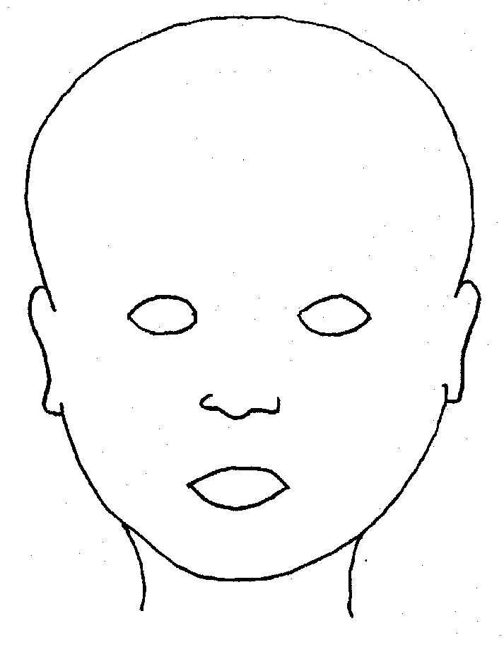 |  | 
FRONT |  | BACK
 |  | 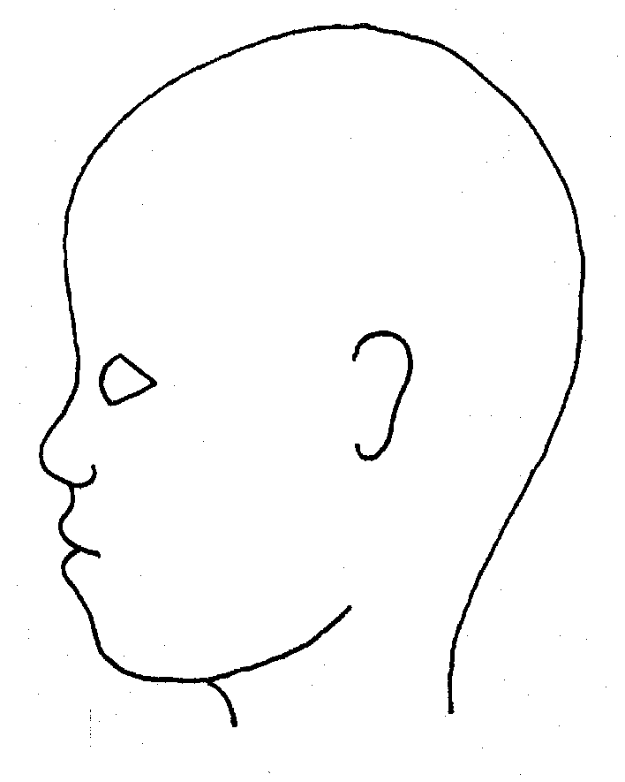
RIGHT |  | LEFT

Name of pupil: |  |  | Date and time of observation:
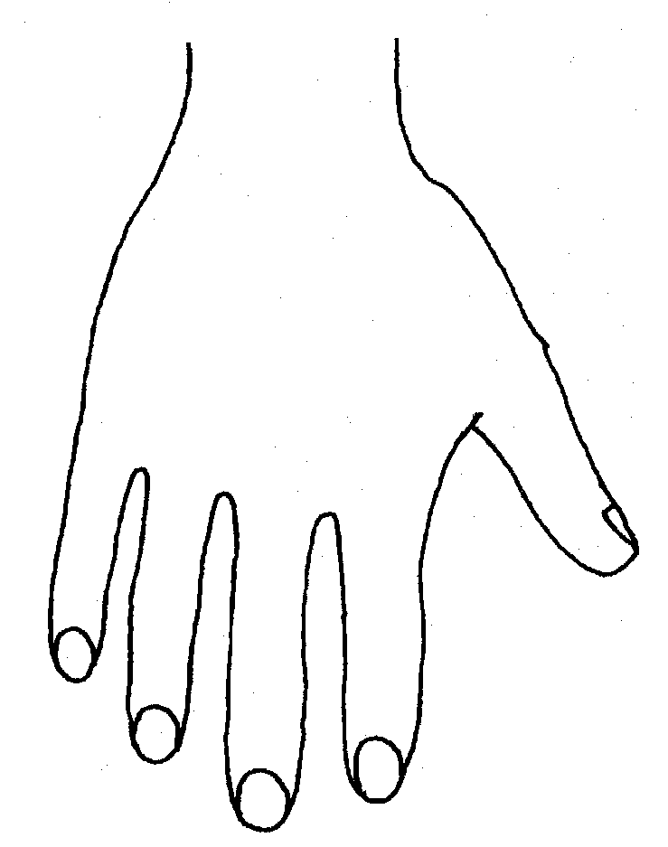 |  | 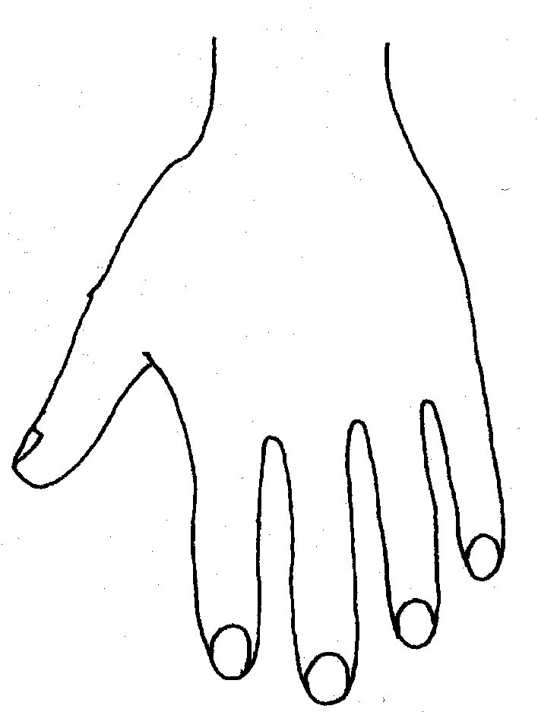
R |  | L
BACK
 |  | 

Name of Pupil: |  |  |  |  |  | Date and time of observation:
 |  |  |  |  | 
R | TOP |  |  | L | R |  | BOTTOM |  |  |  | L
 |  |  |  |  | 
R |  |  |  |  | L
INNER
 |  |  |  |  | 
R |  |  |  |  | L
OUTER
Printed Name, Signature and Job title of staff:

